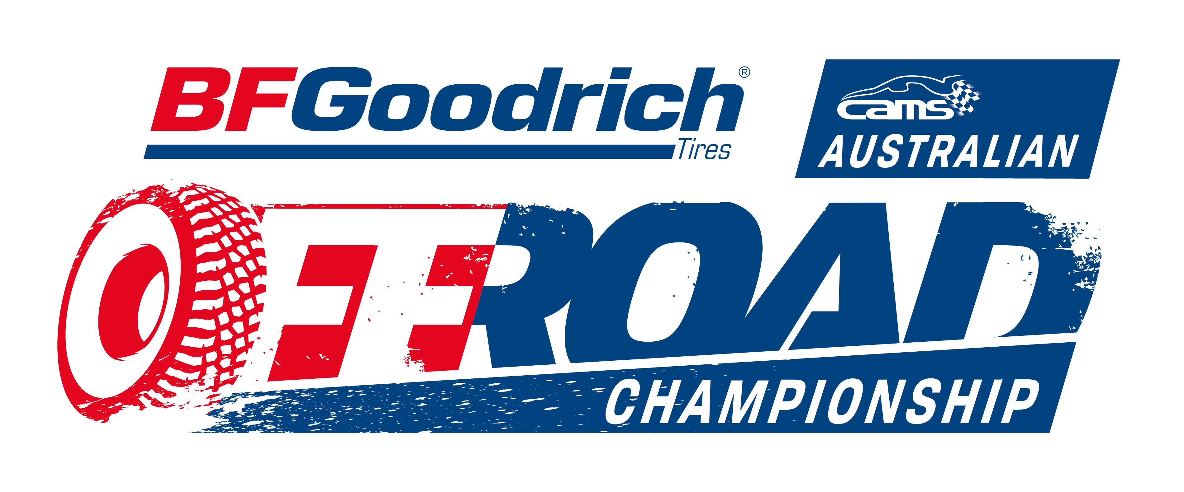
ST. GEORGE 399
4-6 May 2018

OFFICIAL ENTRY FORM – CAMS PERMIT 818/0605/01
HELD UNDER THE INTERNATIONAL SPORTING CODE OF THE FIA & THE NATIONAL COMPETITION RULES OF CAMS
DESCRIPTION OF VEHICLE & TEAM
COMPETITION NUMBER

Driver

Navigator

CLASS

TEAM NAME

VEHICLE

ENGINE CAPACITY (CC)
Make
Forced induction

Please attach picture of vehicle with entry
Sponsor information

Please mark which payment made on form and number of additional navigators if any.
Please quote your RACE VEHICLE NUMBER and DRIVERS SURNAME as reference number when paying by Direct Debit, so that payments can be accounted for.
Direct deposit to- Bank of Queensland BSB 124-011 a/c 1136-1723
South East Queensland Off Road Racing Association
Australian Championship  Entry before 10th April 2018 | $700.00
Queensland Championship  Entry before 10th April 2018 | $300.00
Australian Championship  Entry 11th April -27 April 2018 | $750.00
Queensland Championship  Entry 11th April -27 April 2018 | $350.00
Additional Navigators | $20.00 each
TOTAL PAID | $

Competition number registered with CAMS YES NO

Competing for QLD Championship points YES NO

-------------------------------------------------------------------------------------------------------------------------------------------------------
Office use

Paid
Date received
Additional navigators
QLD only
Club affiliation

Log book #

COMPETITOR (FORMERLY ENTRANT)
FULL NAME
POSTAL ADDRESS
MOBILE PHONE #
CAMS LICENCE #

CAMS AFFILIATED CAR CLUB

Membership #
EMAIL
ALLERGIES

DRIVER (POINT SCORER)
FULL NAME
POSTAL ADDRESS
MOBILE PHONE #
CAMS LICENCE #

CAMS AFFILIATED CAR CLUB

Membership #
EMAIL
ALLERGIES

CO DRIVER / NAVIGATOR 1 (POINT SCORER)
FULL NAME
POSTAL ADDRESS
MOBILE PHONE #
CAMS Licence #
CAMS affiliated car club
Membership #
EMAIL
ALLERGIES

CO DRIVER / NAVIGATOR 2
FULL NAME
POSTAL ADDRESS
MOBILE PHONE #
CAMS Licence No
CAMS affiliated car club
Membership No
EMAIL
ALLERGIES

CO DRIVER / NAVIGATOR 3
FULL NAME
POSTAL ADDRESS
MOBILE PHONE #
CAMS LICENCE #
CAMS affiliated car club
Membership No
EMAIL
ALLERGIES

All original forms must be presented at documentation

DISCLAIMER
EXCLUSION OF LIABILITY, RELEASE AND ASSUMPTION OF RISK
COMPETITORS AND/OR COMPETING CREWS IN OFF ROAD EVENTS
I/We being the competitor/s of the vehicle described on this Entry Form wish to enter that vehicle for the above event.
For competitors competing crew members, pit and service crew
I/We being the competitor/s and/or driver and/or co-driver and/or navigator, certify that the particulars on this form are true and correct in every particular, to the best of my/our knowledge and belief.
I/We declare that I/we have read and understood the Supplementary Regulations issued for the event, and agree to be bound by them and the provisions of the National Competition Rules of the Confederation of Australian Motor Sport Limited (“CAMS”).
In exchange for being able to attend or participate in the event (including entering the event), I agree:
• to release CAMS and the Entities to the extent that any or all of them providing Recreational Services from liability for:
• my death; • any physical or mental injury (including the aggravation, acceleration or recurrence of such an injury); • the contraction, aggravation or acceleration of a disease; • the coming into existence, the aggravation, acceleration or recurrence of any other condition, circumstance, occurrence, activity, for of behaviour, course of conduct or state of affairs;
I/we acknowledge that: • the risks associated with attending or participating in the event include the risk that I may suffer harm as a result of: • motor vehicles (or parts of them) colliding with other motor vehicles, persons or property; • other participants acting dangerously or with lack of skills • acts of violence and other harmful acts (whether intentional or inadvertent) committed by persons attending or participating in the event; and • the failure or unsuitability of facilities (including grand-stands, fences and guard rails) to ensure the safety of persons or property at the event. • motor sport is dangerous and that accidents causing harm can and do happen and may happen to me.
I accept the conditions of, and acknowledge the risks arising from, attending or participating in the event and being provided with the event services by CAMS and the Associated Entities. I understand that this disclaimer is not intended to exclude any valid claim I may have under the CAMS Personal Insurance Scheme.

COMPETITOR NAME | SIGNATURE | DATE
DRIVER NAME | SIGNATURE | DATE
CO DRIVER / NAVIGATOR | SIGNATURE | DATE
1
CO DRIVER / NAVIGATOR | SIGNATURE | DATE
2
CO DRIVER / NAVIGATOR | SIGNATURE | DATE
3
PIT CREW NAME | SIGNATURE | DATE
PIT CREW NAME | SIGNATURE | DATE
PIT CREW NAME | SIGNATURE | DATE
PIT CREW NAME | SIGNATURE | DATE

For persons under the age of 18 years the following parent/guardian consent must be completed.
PARENT/ GUARDIAN CONSENT – PERSONS UNDER 18 YEARS OLD

I………………………………………………………………………………………………………of [Address] ……………………………………………………………………….…………………… am the parent/guardian* of …..…………………..………………………………………………..
the above-named ("the minor") who is under 18 years old. I have read this document and understand its contents, including the exclusion of liability and assumption of risk, and have explained the contents to the minor. I consent to the minor attending/participating in* the event at his/her own risk. Signed……………………………………………………. Date…………………………….
Parent/Guardian*

